**Meeting with Representatives from Suzhou Industrial Park**

Cloud-based TMT industry is experiencing ever booming and robust development in China, which is mirrored by flocks of hi-tech startups and MNCs print and spread their footprints in China.

As the leading modern technology intensive park of China, Suzhou Industrial Park (SIP, the largest government-to-government level cooperative park in China ) is also taking on full fledging vitality for supporting hi-tech start-ups as well as innovation driven TMT companies by relying on her unique geographic location (only 50 miles to Shanghai) 、existing matured investment environment (140+Fortune 500 company invested projects in Suzhou, and over 3000+ hi-tech start-ups) and pro-business government work code. As the service-centric government team, It’s our core pursuit to offer an all-round value added service solution to each existing and new companies, including shared IT platform, talents hiring and training, business matching, financing, office property facility and favorable government policy implementation.

On October 20th (Monday), we are very pleased to visit Los Angles area to meet local start-up teams, hi-tech entrepreneurs and company representatives, and by this chance, we hope we can bring and clarify the latest hi-tech supportive and hi-tech incubating information to all the people interested.

**The proposed agenda：**

1. SIP Hi-tech Eco-system Presentation；
2. General Q&A
3. Networking

**Meeting time：15:30-18:00，** Oct. 20, 2014 (Monday)

**Meeting Venue**: UCLA Engineering V, Room 3129.

Contact person: Dr. Wei Kao‘s cell number at 310-753-0953.

苏州园区代表团将于10月20日上午从硅谷来LA，现拟于10月20日下午15：30- 18:00在UCLA Engineering V, Room 3129与有意回国创业的团队进行交流。欢迎有真实兴趣回国创业的TMT项目或其他领域的项目团队成员参加。

**Delegates：**

Mr. Chaoqun ZHU Deputy GM of SISPARk Hi-tech Promotion Department

Mr. Nan XIAO Deputy Manager of Division I, SISPARk Hi-tech Promotion Department

Mr. Jinyan HUANG Senior Executive of Division III, SISPARk Hi-tech Promotion Department

**主办： SISPARK**

**UCLA ITA （http:.//www.ita.ucla.edu）**

**SIP-UCLA ITA （**[**http://www.szucla.org**](http://www.szucla.org) **）**

**Direction:** [**http://maps.ucla.edu/campus/**](http://maps.ucla.edu/campus/)

**Companies in SISPARK：**





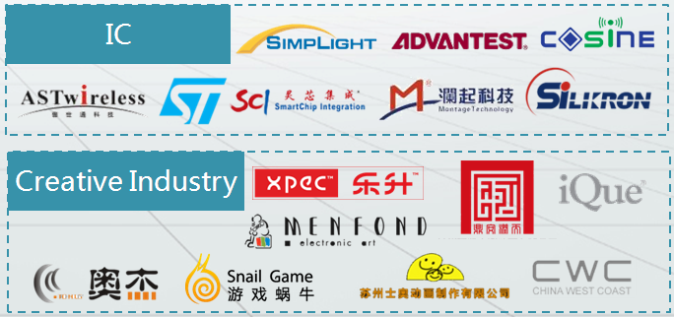

**Dimensional code of Wechat：**

